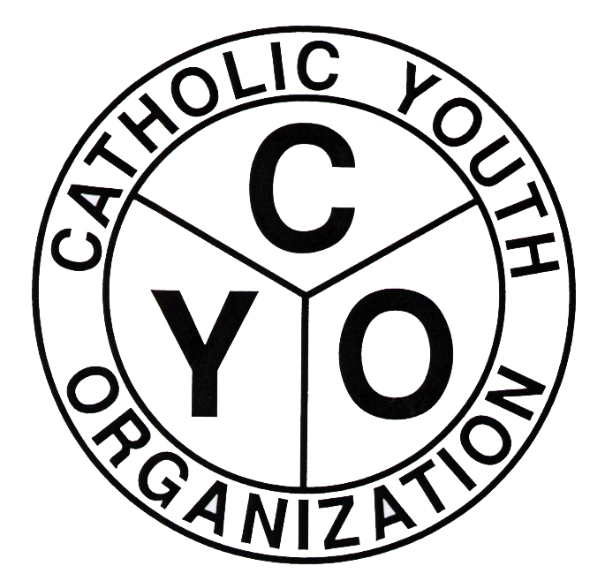
Catholic Youth Organization
Diocese of Brooklyn
7200 Douglaston Parkway,
Douglaston, NY 11362
Tel.: 718.281.9548
Fax.: 718.281.9557
2024-25 CYO BOYS’ BASKETBALL DIOCESAN LEAGUE
ENTRY FORM
PARISH: _______________________________________________________________________
SUB NOVICE # TEAMS
SUB NOVICE “2” (’17) ________
SUB NOVICE “3” (16) ________

PLEASE FILL IN THE NUMBER OF TEAMS YOU ARE ENTERING FOR EACH DIVISION
CHAMPIONS LEAGUE
(ABOVE AVERAGE)
COMPETITIVE LEAGUE
(AVERAGE)
DEVELOPMENTAL LEAGUE
(BELOW AVERAGE)

PEE WEE (’15)
NOVICE (’14)
BANTAM (’13)
ROOKIE (’12)
INTERMEDIATE (’11)
ENTRY FEE: $250.00 PER TEAM TOTAL # OF TEAMS __________ TOTAL AMOUNT DUE: ______________

PARISH ATHLETIC REPRESENTATIVE ATHLETIC DIRECTOR
NAME ________________________________ _____________________________________
CYO USE ONLY
Home Phone # __________________________ ___________________________
Cell Phone # ____________________________ ___________________________
Email __________________________________ _______________________________________
ENTRY APPROVED BY:
PAR: _______________________________ PASTOR/MODERATOR: _________________________________

BOYS’ BASKETBALL ENTRY FOR 2024-25
PARISH: ________________________________________
SCHEDULING CONFLICTS: (PARISH FUNCTIONS MUST BE RELIGIOUS AND/OR EDUCATIONAL)
TEAM DATE TIME(S) REASON

COACHES INFORMATION SHEET AND COURT AVAILABILITY FORM MUST ACCOMPANY THIS ENTRY FORM
Entry Forms are due: OCTOBER 6, 2024
Completed rosters are due: OCTOBER 25, 2024
Waiver Requests are due: OCTOBER 21, 2024
Schedule Distribution: OCTOBER 23, 2024
*Schedules will also be available on the CYO website (www.cyodob.org)
Boys Regular Season games will begin the weekend of November 2, 2024.
NOTE: Entries for Pee Wee through Intermediate divisions includes entry into the Diocesan Playoffs. PARs/ADs must notify the CYO if a team will not participate in the diocesan playoffs by the date announced by the CYO during the season. See Basketball Fact Sheet/Athletic Manual for complete playoff policy.

